**NGO Donor & Volunteer Management CRM**

**Phase 1**:

**Problem Understanding & Industry Analysis Goal**: To understand what challenges NGOs face in managing donors, volunteers, and funds, and how a CRM can make their work easier and more transparent. Requirement Gathering

• “We have so many donors, but we don’t have one place to see their history and preferences.”

• “We spend hours generating receipts and sending thank-you messages manually.”

• “Funds get spread across multiple projects, but it’s hard to track exactly where they went.” • “Volunteers sign up to help, but managing their schedules is chaotic.”

• “Our donors want to know the impact of their contribution, we need clear reports.” So, the system must:

• Track all donors and their donations.

• Generate automated receipts.

• Show where money is being used.

• Manage volunteer records and schedules.

• Produce impact reports that can be shared with donors. Stakeholder Analysis

• Admin: Sets up Salesforce and makes sure everything works smoothly.

• NGO Manager: Wants a big-picture view — which projects are running, how much funding is available, and what outcomes have been achieved.

• Donor Relations Officer: Wants to maintain good relationships with donors, thank them, and encourage them to keep contributing.

• Volunteer Coordinator: Needs to schedule volunteers, assign them to events, and make sure they feel valued.

• Finance Team: Cares about receipts, compliance, and ensuring money is properly allocated.

• Donors: Want to know their money is being used well and transparently.

• Volunteers: Want to contribute their time but need clarity about when, where, and how they are needed.

Business Process Mapping

1. A donor contributes (maybe online, maybe in person).

2. Their details and the donation are logged in the CRM.

3. A receipt is instantly generated and emailed to them, along with a thank-you note.

4. The NGO allocates the donation to a project; for example, “Child Education Drive.”

5. Volunteers are assigned shifts to execute the project.

6. Once the project is done, an impact report (like “200 children received books”) is generated.

7. This report is sent back to the donor, so they feel connected and motivated to support again.

Industry-specific Use Case Analysis

• Donors give money, but they want to see trust and transparency.

• Funds are usually tied to specific causes or campaigns, so tracking is essential.

• Volunteers are as important as funds — without them, projects don’t succeed.

• NGOs must show impact (numbers, stories, outcomes) to survive and grow. AppExchange Exploration There are existing nonprofit apps (like Salesforce Nonprofit Success Pack - NPSP). But for learning, we’ll build a simplified custom CRM with objects for Donors, Volunteers, Donations, Campaigns, and Fund Allocation

**Phase 2 :**

**Step-by-Step: Org Setup & Configuration**

*(NGO Donor & Volunteer Management CRM)*

**1. Salesforce Editions — check & pick one**

**Why:** The Salesforce Edition determines what features are available (e.g., Sandboxes, API access, license types).

**Steps:**

1. Setup → Quick Find → **Company Information**.
2. Look at **Organization Edition** and **User Licenses**.

**For learning/practice:** Use a **Developer Edition** (free) or Trailhead Playground.  
**For production NGOs:** Consider **Enterprise Edition + Nonprofit Cloud (NPSP)**.

**2. Company Profile Setup (Company Information & Org Defaults)**

**Why:** Defines org-level defaults for time zone, currency, locale, and identity.

**Steps:**

1. Setup → Quick Find → **Company Information** → **Edit**.
2. Fill in:
   * **Company Name** (e.g., *Helping Hands NGO*)
   * **Primary Contact / Phone / Address**
   * **Default Time Zone** → Asia/Kolkata
   * **Locale & Language** → English (India)
   * **Default Currency** → INR

**Extras:**

* To support multiple currencies: Setup → Company Settings → **Currency Management** (irreversible in production).

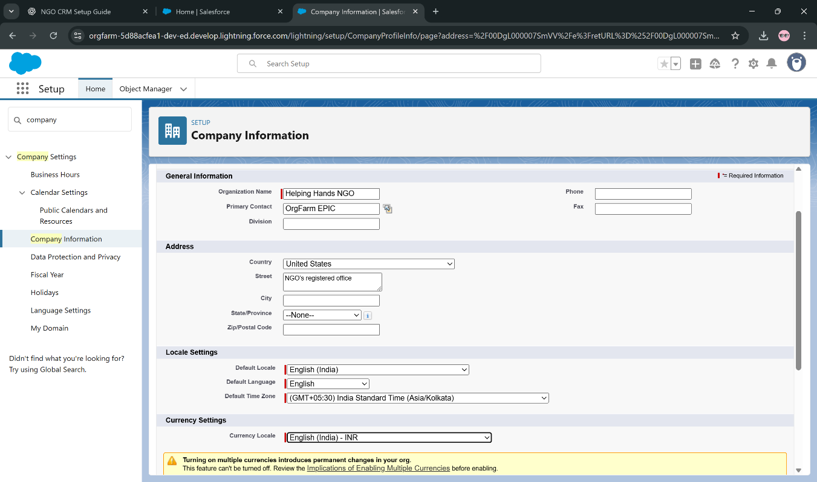

**3. Business Hours & Holidays**

**Why:** Used for scheduling volunteers/events and case escalation rules.

**Business Hours:**

1. Setup → Quick Find → **Business Hours** → **New Business Hours**.
2. Name: “NGO Business Hours”, Time Zone = Asia/Kolkata.
3. Define Mon–Sat: 9:00 AM – 6:00 PM; leave Sunday blank.
4. 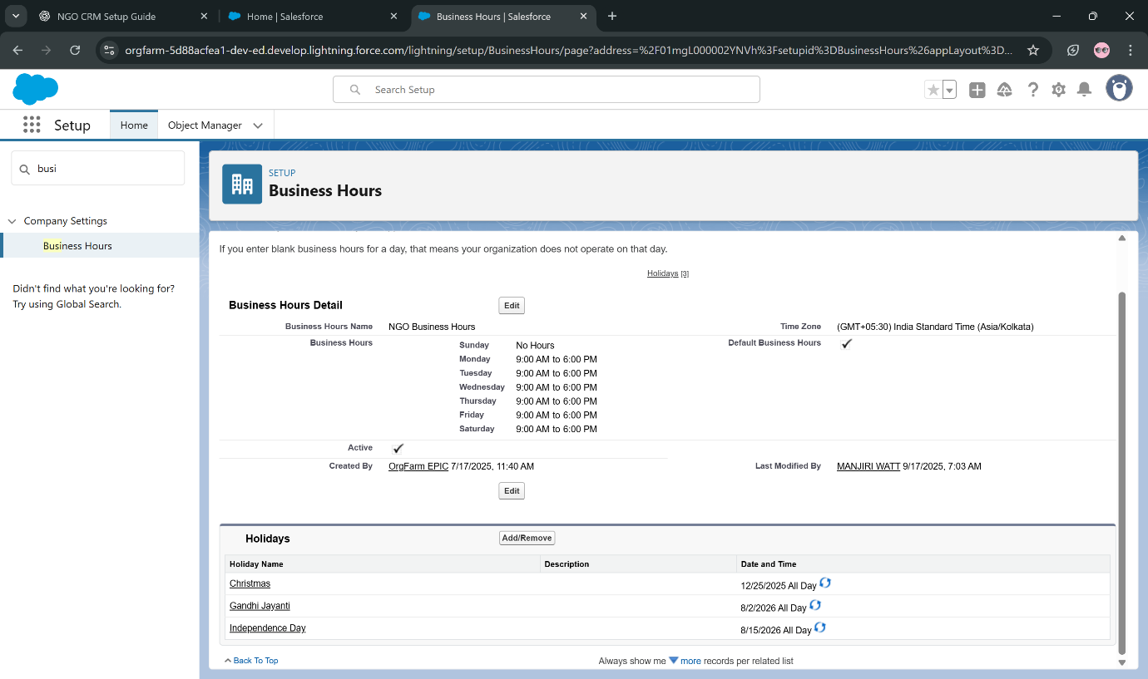Save.

**Holidays:**

1. Setup → Quick Find → **Holidays** → **New Holiday**.
2. Add “Independence Day” (15 Aug), “Gandhi Jayanti” (2 Oct), etc. → **Save**.
3. Open each holiday → **Add Business Hours** → assign “NGO Business Hours”.

**4. Fiscal Year Settings**

**Why:** Ensures reporting and rollups follow your NGO’s fiscal calendar.

Salesforce names fiscal years by the year they **end** (e.g., Apr 2025–Mar 2026 = FY2026).

**Steps:**

1. Setup → Quick Find → **Fiscal Year**.
2. Choose **Standard Fiscal Year**.
3. Set **Start Month = April** (India).
4. 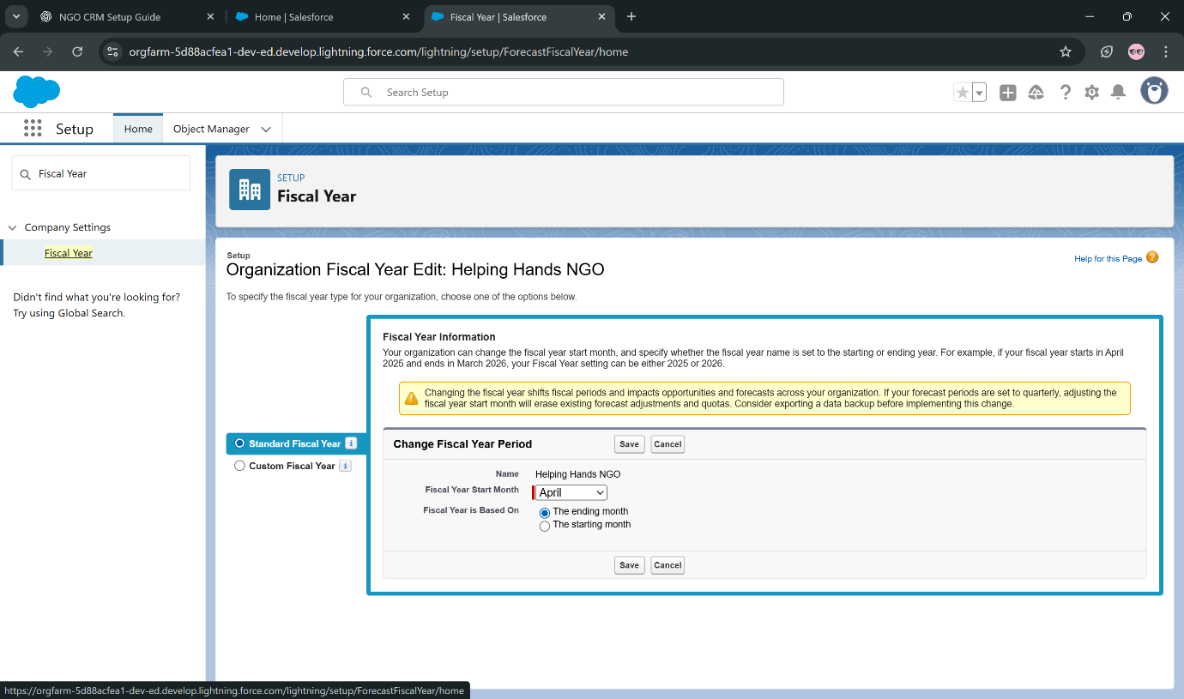Save.

**5. User Setup & Licenses**

**Why:** Users need accounts with licenses and roles to access the system.

**Create User:**

1. Setup → Quick Find → **Users** → **New User**.
2. Fill:
   * Name, Email, Username (must be unique across Salesforce).
   * License (Salesforce / Platform / Chatter Free).
   * Profile (choose from available).
   * Role (assign later if roles are set up).
3. Save.

**Check Licenses:** Setup → Company Information → **User Licenses** (used vs available).

**Example Mapping for NGO:**

* NGO Manager → Salesforce License + NGO Manager Profile
* Finance Officer → Salesforce License + Finance Profile
* 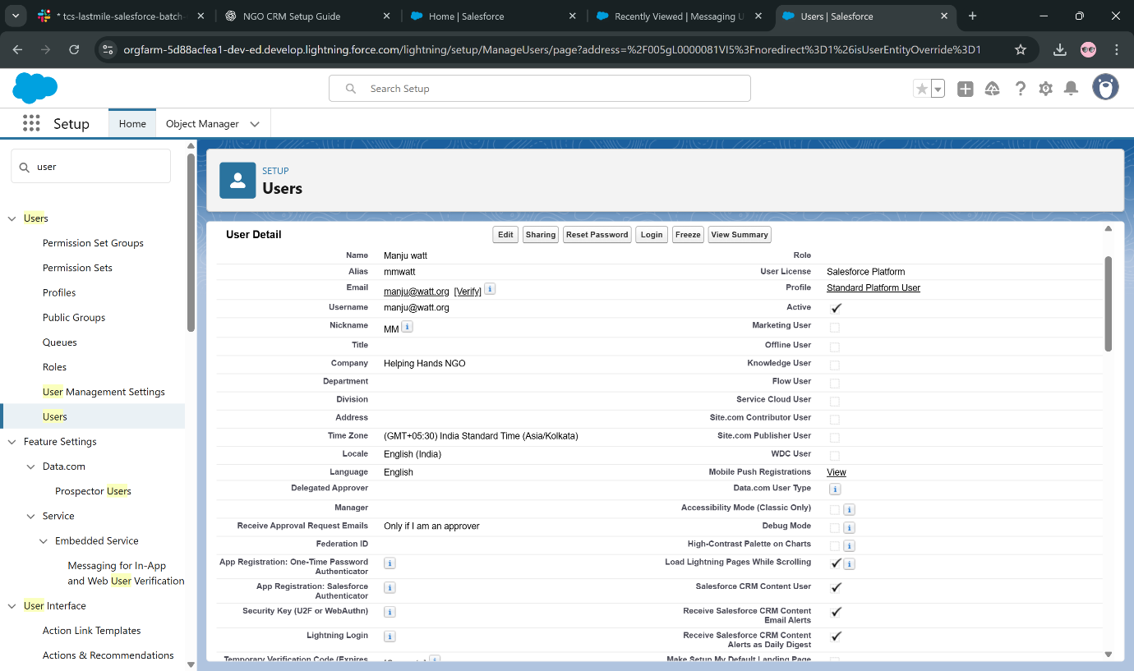Volunteers → Platform / Chatter Free + Volunteer Profile

**6. Profiles — Create & Configure**

**Why:** Profiles control object, field, and system permissions.

**Steps:**

1. Setup → Profiles → choose a standard profile → **Clone**.
2. 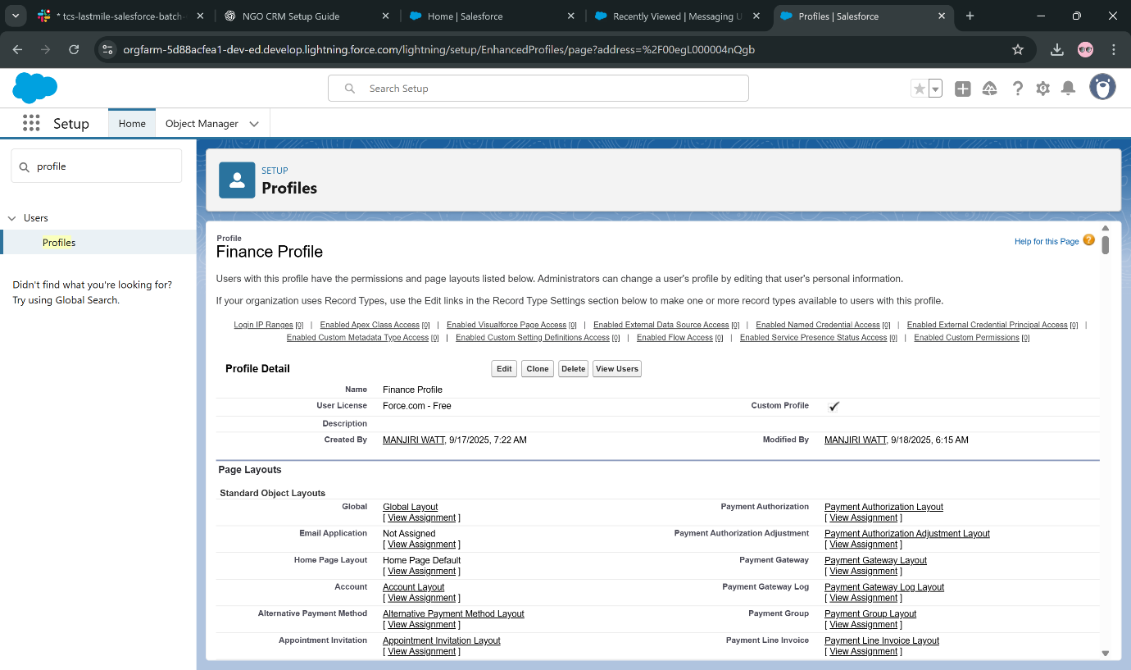Name (e.g., Finance Profile) → Save.
3. Edit **Object Settings**: Donations → check Read/Create/Edit/Delete as required.
4. Adjust **Field-Level Security** to hide sensitive donor info.
5. Configure **Tab Settings** (Default On/Off/Hidden) and **Assigned Apps**.
6. Set **System Permissions** (e.g., Export Reports).
7. (Optional) Restrict with **Login Hours / IP Ranges**.
8. Assign to users via User record.

**7. Roles — Data Visibility Hierarchy**

**Why:** Controls who can see records owned by others. Higher roles inherit access.

**Steps:**

1. Setup → Roles → **Set Up Roles**.
2. Click **Add Role** under a parent.
   * Executive Director (top role)
   * NGO Manager → Finance Officer, Donor Relations Officer, Volunteer Coordinator → Volunteers.
3. Save and assign users.

**8. Permission Sets — Grant Extra Access**

**Why:** Add permissions without cloning/editing profiles.

**Steps:**

1. Setup → Permission Sets → **New**.
2. Label & API Name → Save.
3. Add Object Settings, Field Permissions, or System Permissions.
   * Example: “Export Reports Access” → grant only to Finance users.
4. Assign users → **Manage Assignments** → Add.

**9. OWD (Organization-Wide Defaults)**

**Why:** Defines baseline visibility for each object.

**Steps:**

1. Setup → Sharing Settings → **Edit OWD**.
2. Set:
   * Donors (Contacts) = Private
   * Donations (Custom Object) = Private
   * Volunteers = Public Read/Write
   * Campaigns = Public Read Only
3. Save.

**10. Sharing Rules**

**Why:** Open up access beyond OWD (e.g., team-wide visibility).

**Steps:**

1. Setup → Sharing Settings → scroll to object → **New Sharing Rule**.
2. Select **Owner-Based** or **Criteria-Based**.
3. Define which records to share → with which Roles/Groups → and at what Access Level.
4. Save.

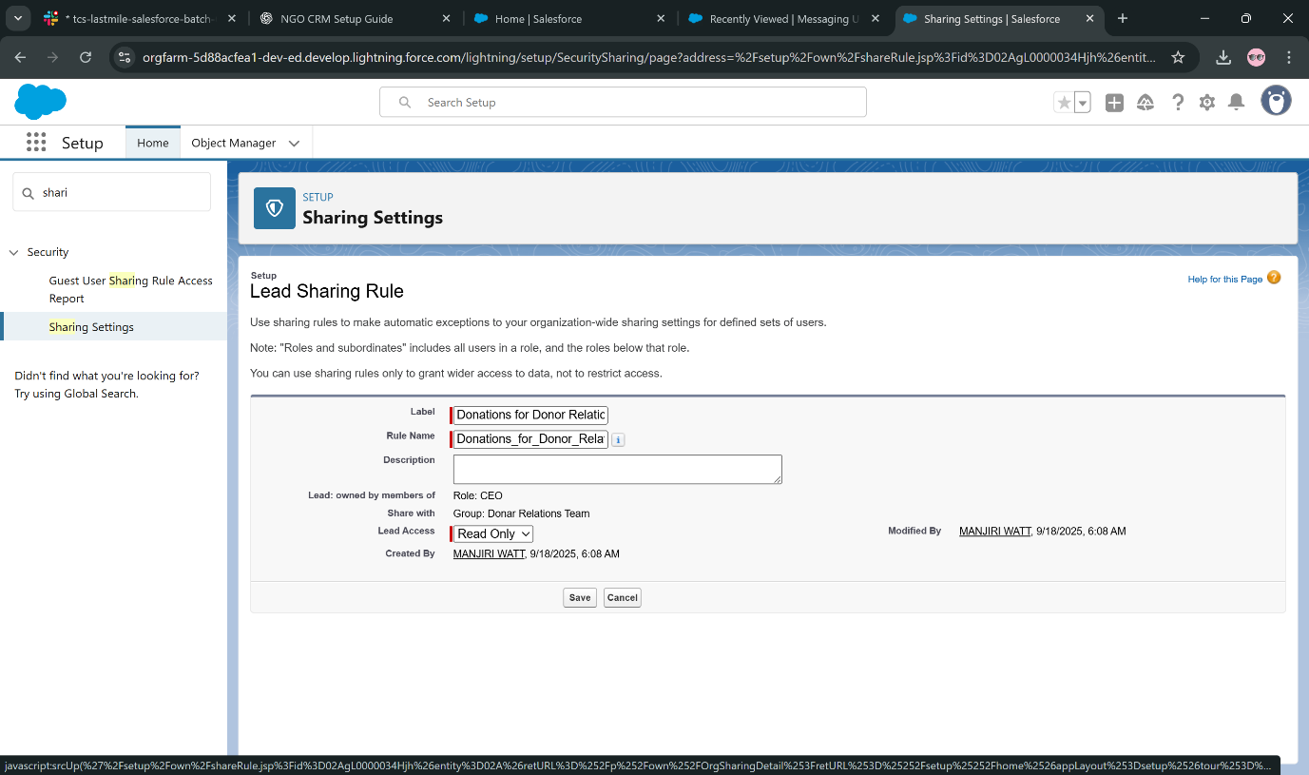**Create Public Groups:** Setup → Public Groups → **New** → add Users/Roles.

**11. Login Access Policies & Security**

**Why:** Control when/how users log in and enable admin support.

**Steps:**

1. Setup → Login Access Policies → enable **Administrators can log in as any user**.
2. In Profiles → set **Login Hours / IP Ranges** as needed.
3. 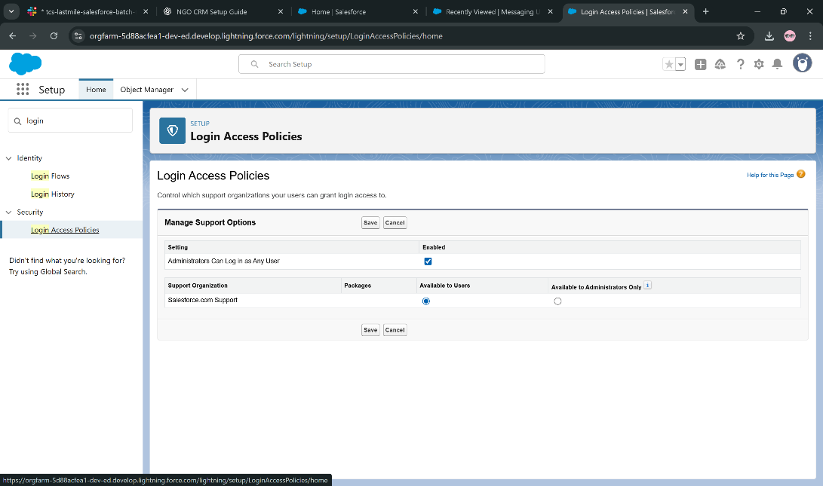Setup → Session Settings → configure session timeout & HTTPS.
4. Setup → Multi-Factor Authentication → enforce MFA for all.

**12. Dev Org Setup**

**Why:** Build/test safely without touching Production.

**Steps:**

1. Sign up at developer.salesforce.com or use Trailhead Playground.
2. 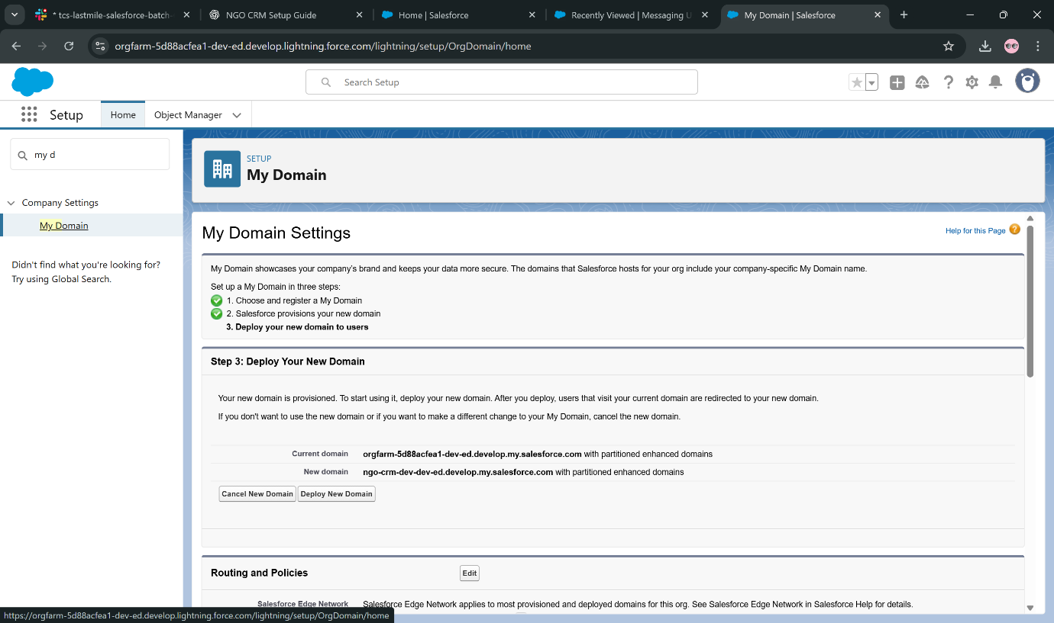Setup → My Domain → register & deploy a unique domain.
3. Setup → Dev Hub → enable (if using Scratch Orgs).
4. Optional: AppExchange → install **Nonprofit Success Pack (NPSP)**.

**Phase 3: Data Modeling & Relationships**

**1) Standard & Custom Objects**

* **Standard Objects**: Already in Salesforce (Account, Contact, Campaign, Opportunity).
* **Custom Objects**: You create your own (e.g., Donation, Volunteer, Program).  
   Setup → **Object Manager** → **Create → Custom Object**.

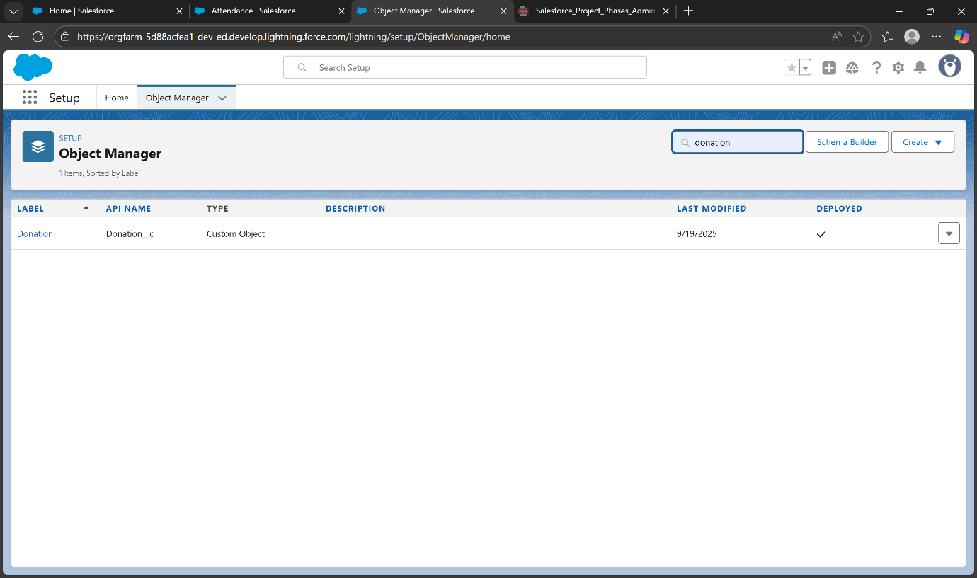

**2) Fields**

* Add data points like Amount, Date, Status.
* Example: On Donation create a field Donation Amount (Currency).  
  Object Manager → pick object → **Fields & Relationships → New**.

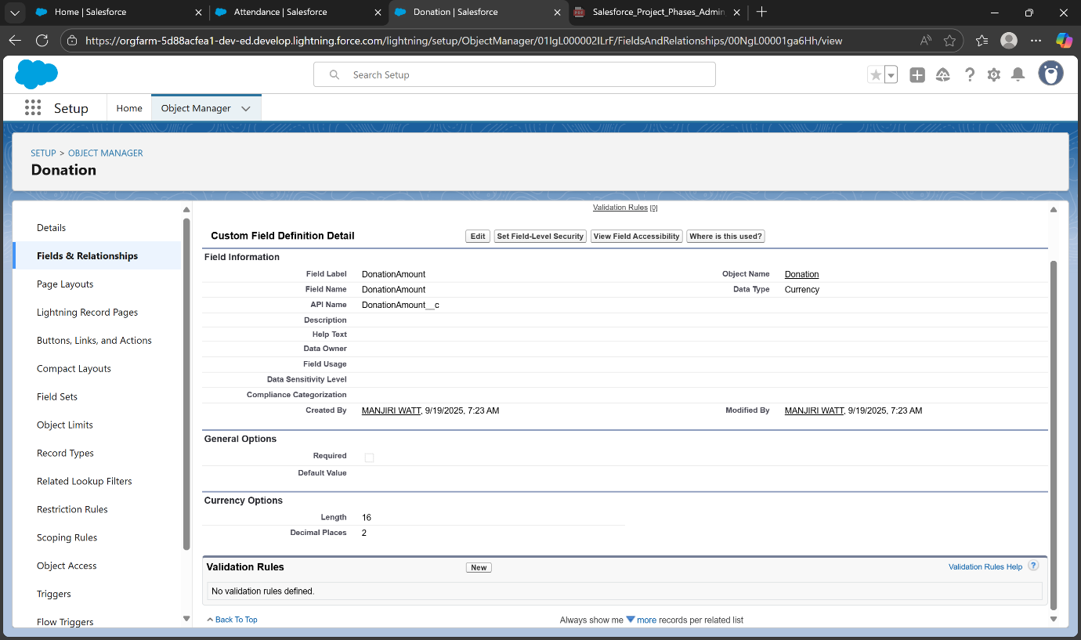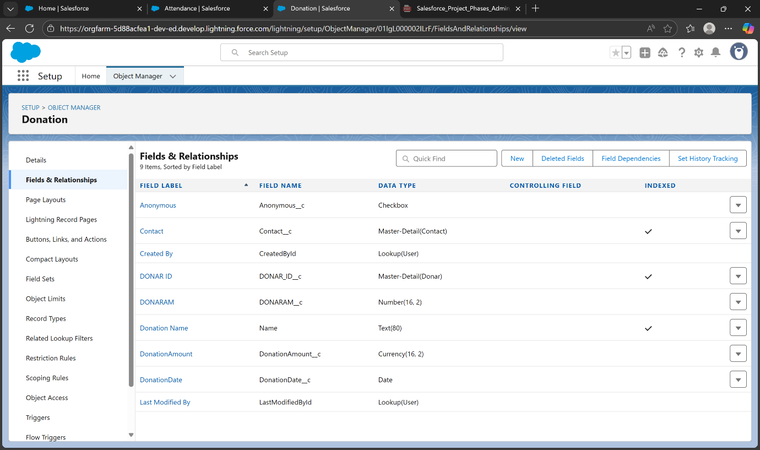

**3) Record Types**

* Let you separate processes/layouts within one object.
* 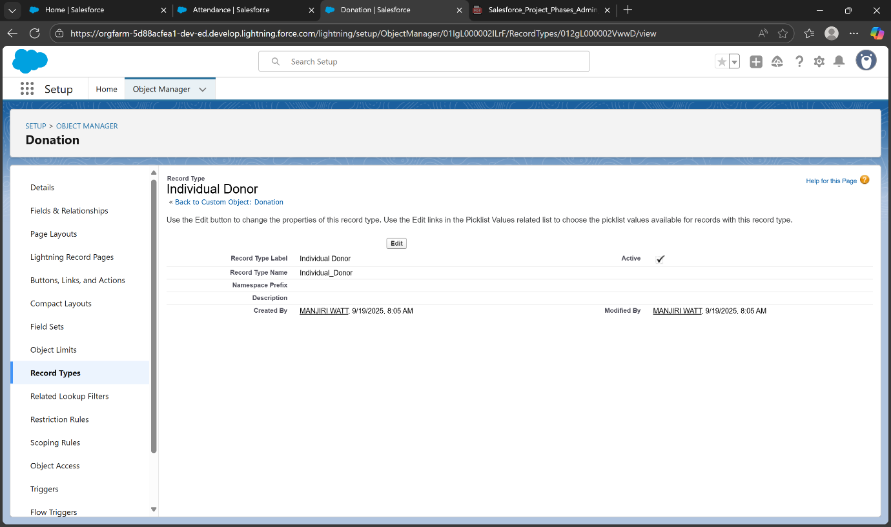Example: Contact = Individual Donor vs Institutional Donor.  
  Object Manager → pick object → **Record Types → New**.

**4) Page Layouts**

* Control which fields/sections show on a record page.
* 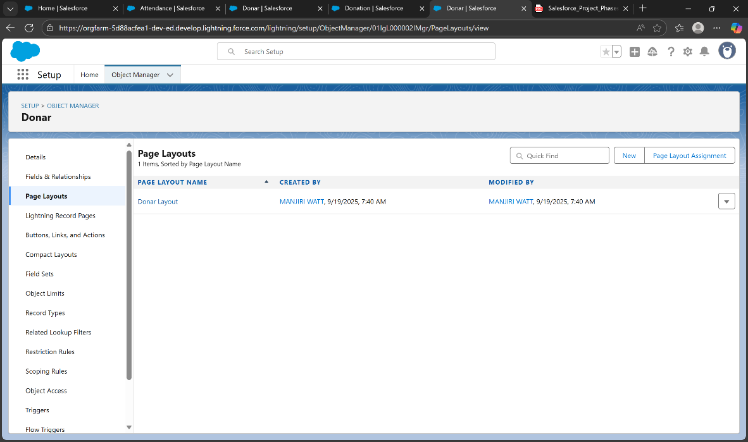Example: Individual Donor layout hides company fields, Institutional layout shows them
* Object Manager → pick object → **Page Layouts → Edit/New**.

**5) Compact Layouts**

* Control fields shown in the record header & Salesforce mobile.
* Example: Show Name, Email, Phone for Donor at top.  
   Object Manager → pick object → **Compact Layouts → New**.

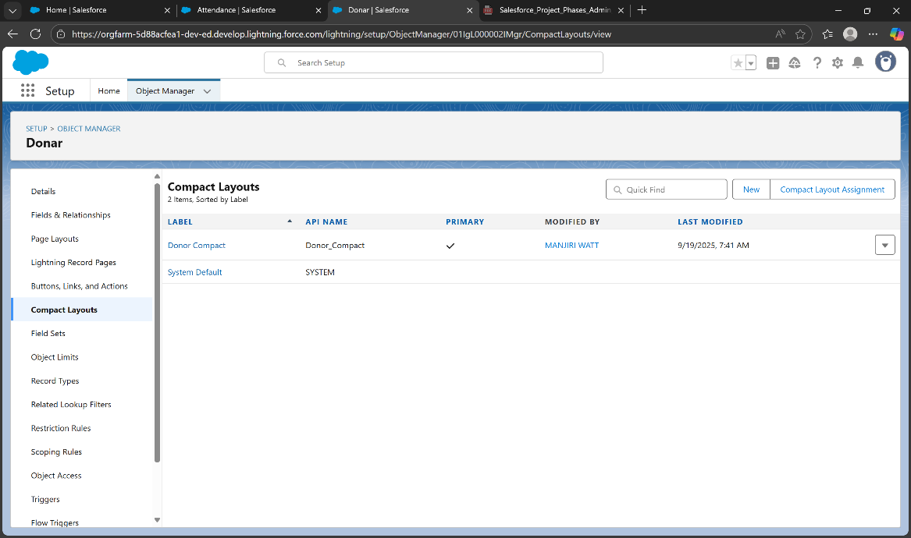

**6) Schema Builder**

* Visual, drag-and-drop view of all objects and fields.
* 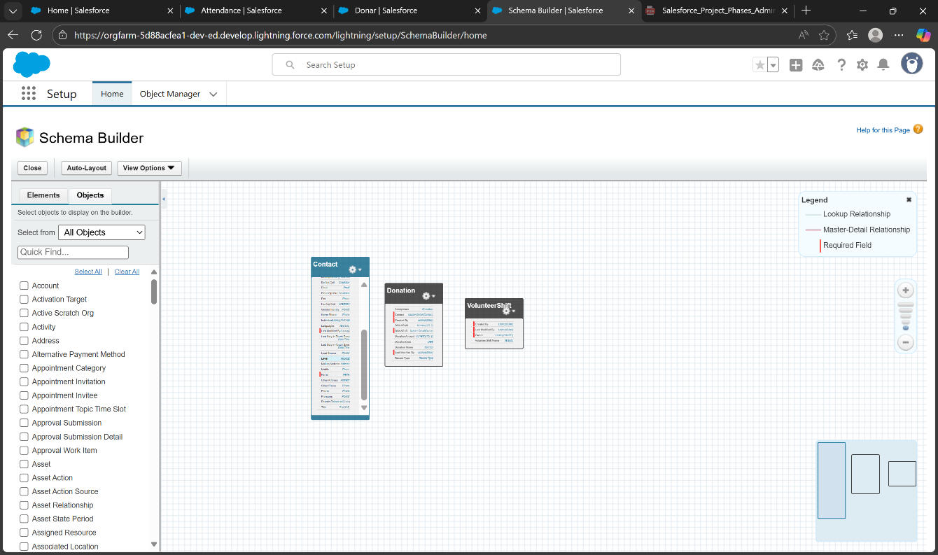Useful for seeing relationships at once.  
  Setup → search **Schema Builder**.

**7) Lookup vs Master-Detail vs Hierarchical Relationships**

* **Lookup**: Loose link (child can exist alone). Ex: Donation → Donor.
* 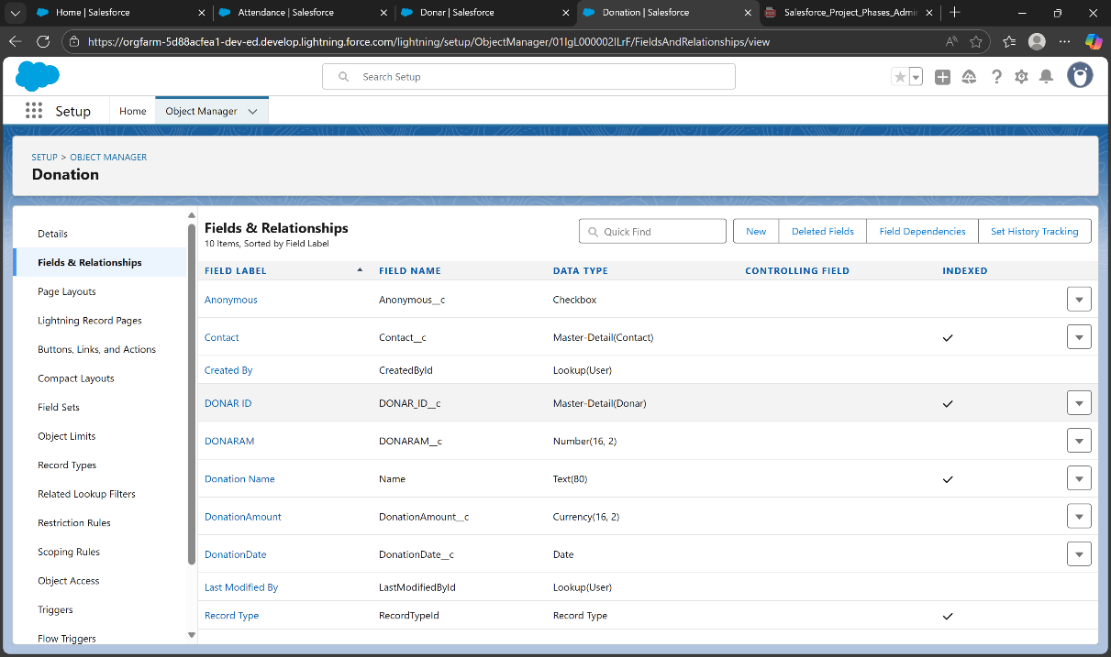**Master-Detail**: Tight link (child depends on parent, rollups possible). Ex: Attendance → Event.
* **Hierarchical**: Only on User object (manager relationships).  
  Object Manager → Fields → New → choose relationship type.

**8) Junction Objects**

* Used for many-to-many.
* 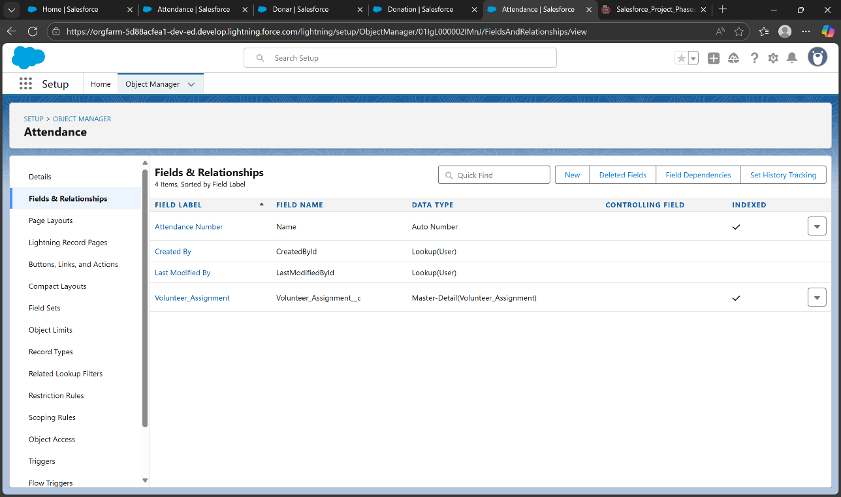Example: Attendance links Volunteers ↔ Events.  
   Create custom object with two **Master-Detail** fields.

**9) External Objects**

* Bring in data stored outside Salesforce (via Salesforce Connect).
* Example: Link external donor DB without importing all records.  
  Setup → search **External Data Sources** → New → Validate & Sync.

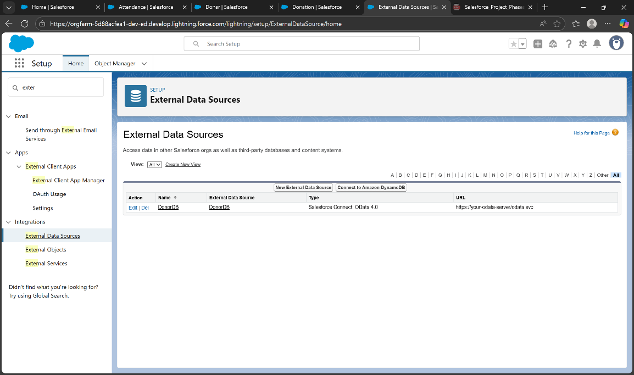

**Phase 4 — Automate & Enforce Rules**

**1) Validation Rules**

* **Purpose:** Block bad data at save (e.g., Donation ≤ 0)
* **Setup:** Object Manager → Donation → Validation Rules → New
* **Formula:** Donation_Amount__c <= 0
* 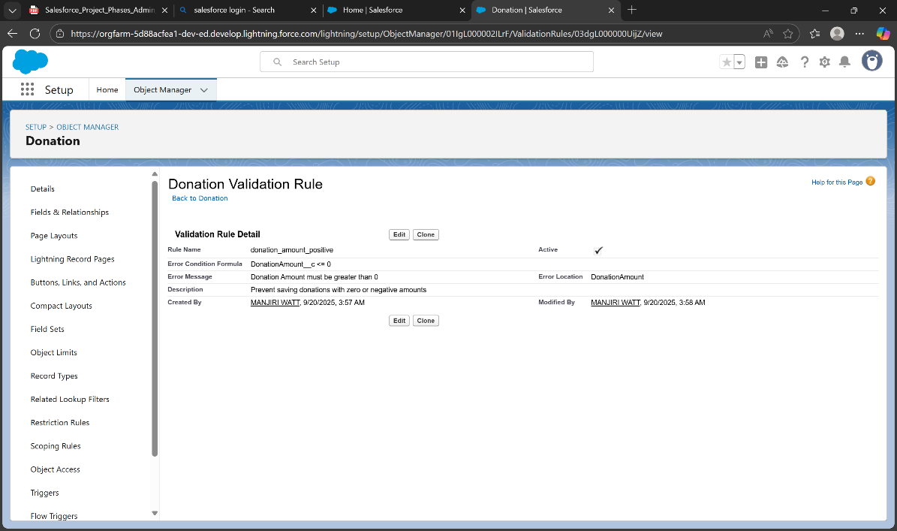**Error Message:** Donation Amount must be greater than 0 → Save & Test

**2) Workflow Rules (legacy)**

* **Use:** Simple automation (Task/Email)
* **Setup:** Workflow Rules → New → Object = Donation → Criteria: Donation_Amount__c > 0 → Add Task/Email → Activate
* **Tip:** Prefer **Flow** for all new automations

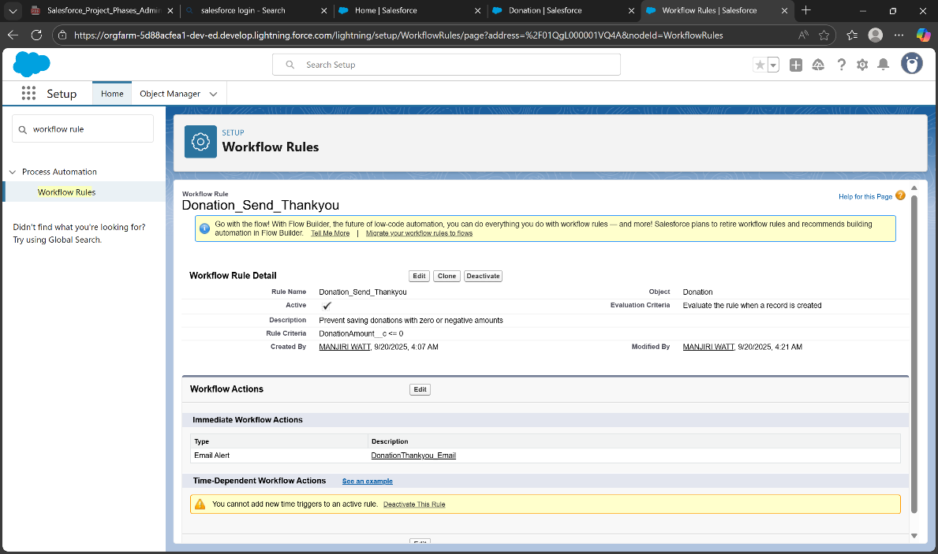

**3) Process Builder (legacy)**

* **Use:** Multi-step automation (update fields, send email)
* **Example:** Donation created → Acknowledged__c = True + Email
* **Setup:** Process Builder → New → Donation → Criteria: Donation_Amount__c > 0 → Immediate Action: Update Records → Activate
* 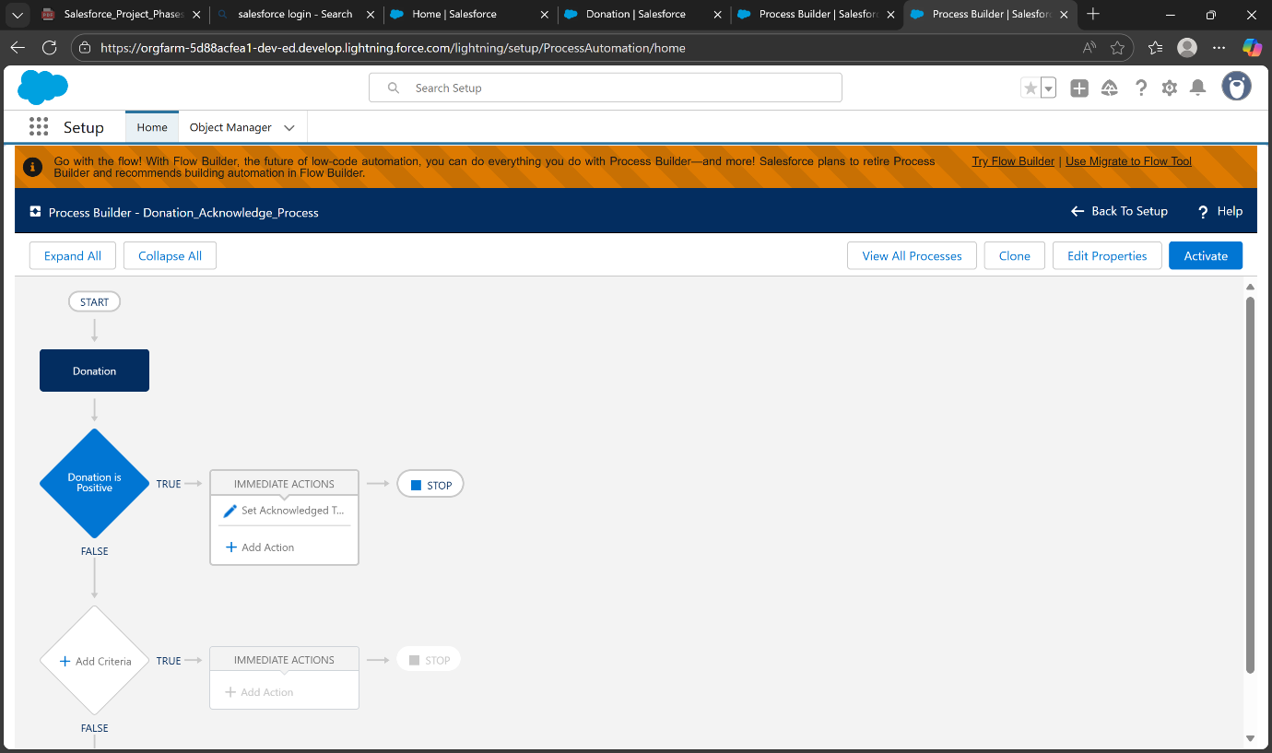**Tip:** Use Flow instead; Process Builder is retiring

**4) Approval Process**

* **Use:** Route for approvals (finance/leadership)
* **Example:** Donations ≥ ₹1,00,000 → Approval
* 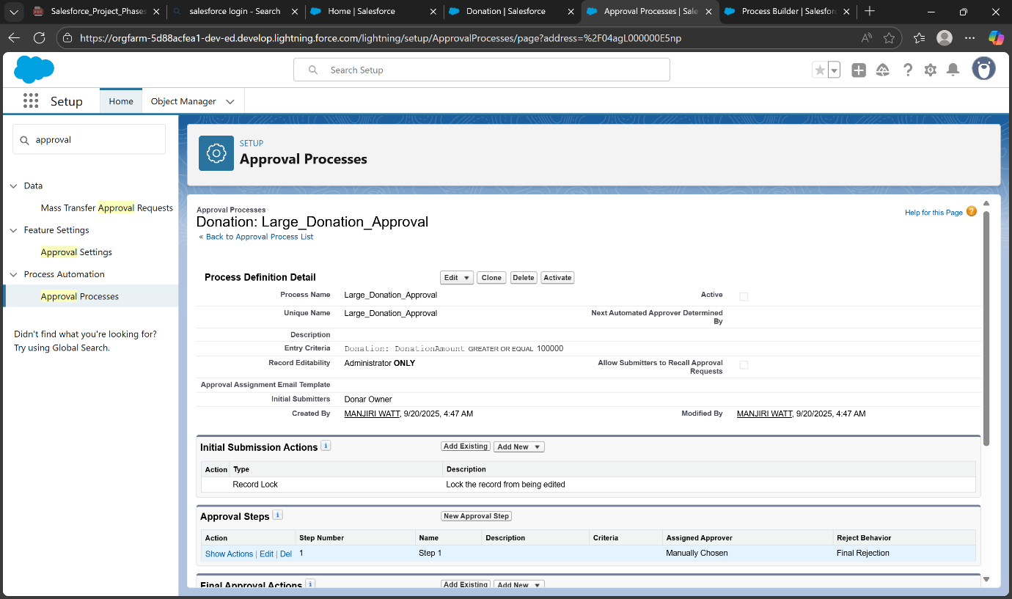**Setup:** Approval Processes → Donation → Jump Start → Entry Criteria: Donation_Amount__c >= 100000 → Approver: Finance → Final Approval: Update Status = Approved + Email → Activate

**5) Flow Builder**

* **Screen Flow:** Volunteer intake → create Contact
* **Record-Triggered Flow:** Donation created → send Email + create Task + Custom Notification
* **Scheduled Flow:** Daily check → donations without receipts → send Email/Task
* **Autolaunched Flow:** Reusable logic (subflow)

**Tip:** Use **Before-save** for fast field updates, **After-save** for emails/tasks/notifications. Always debug first.

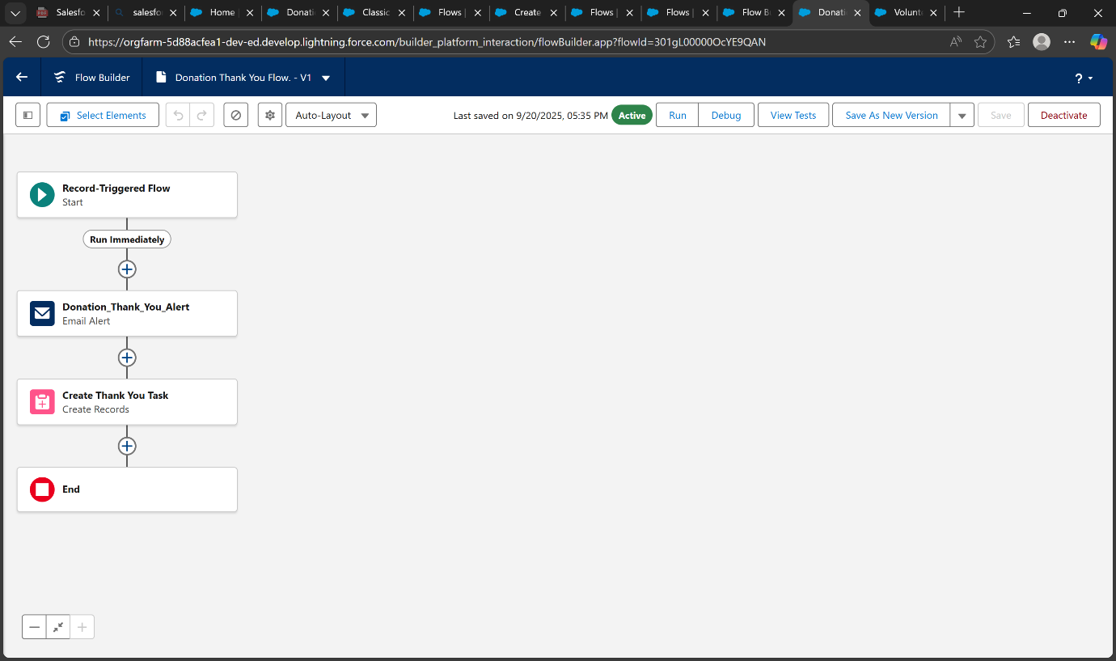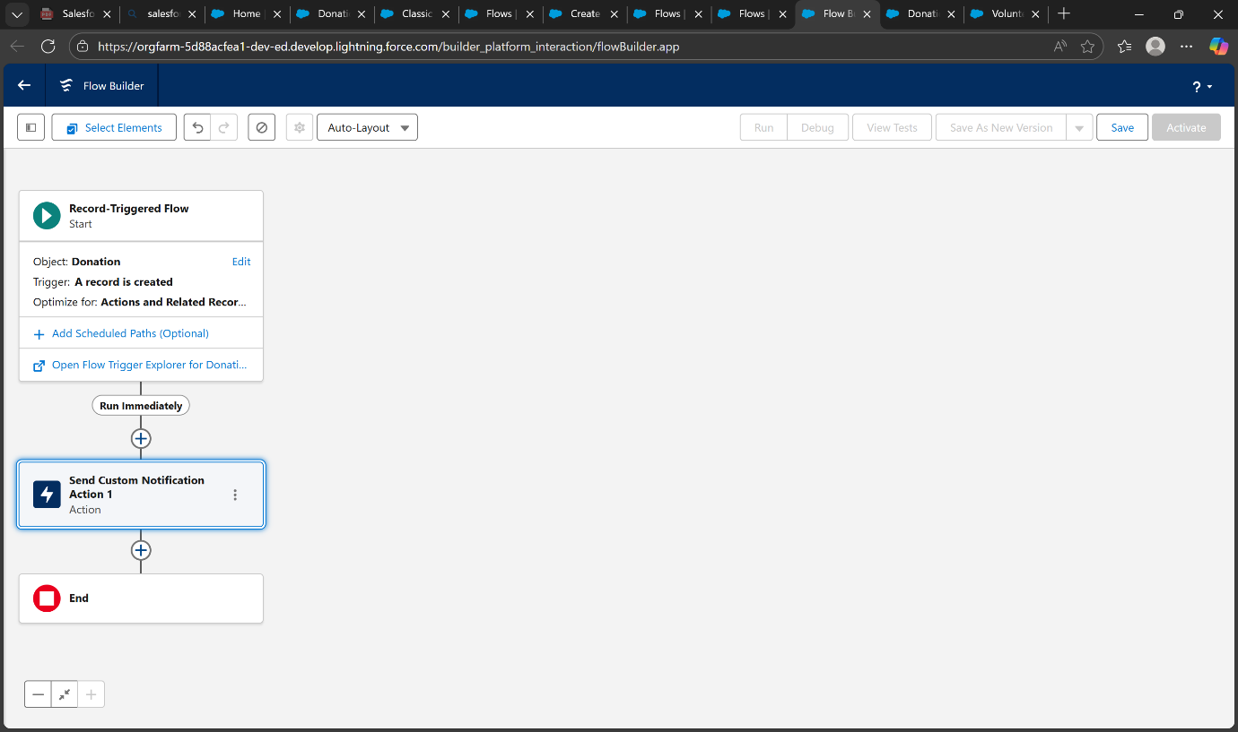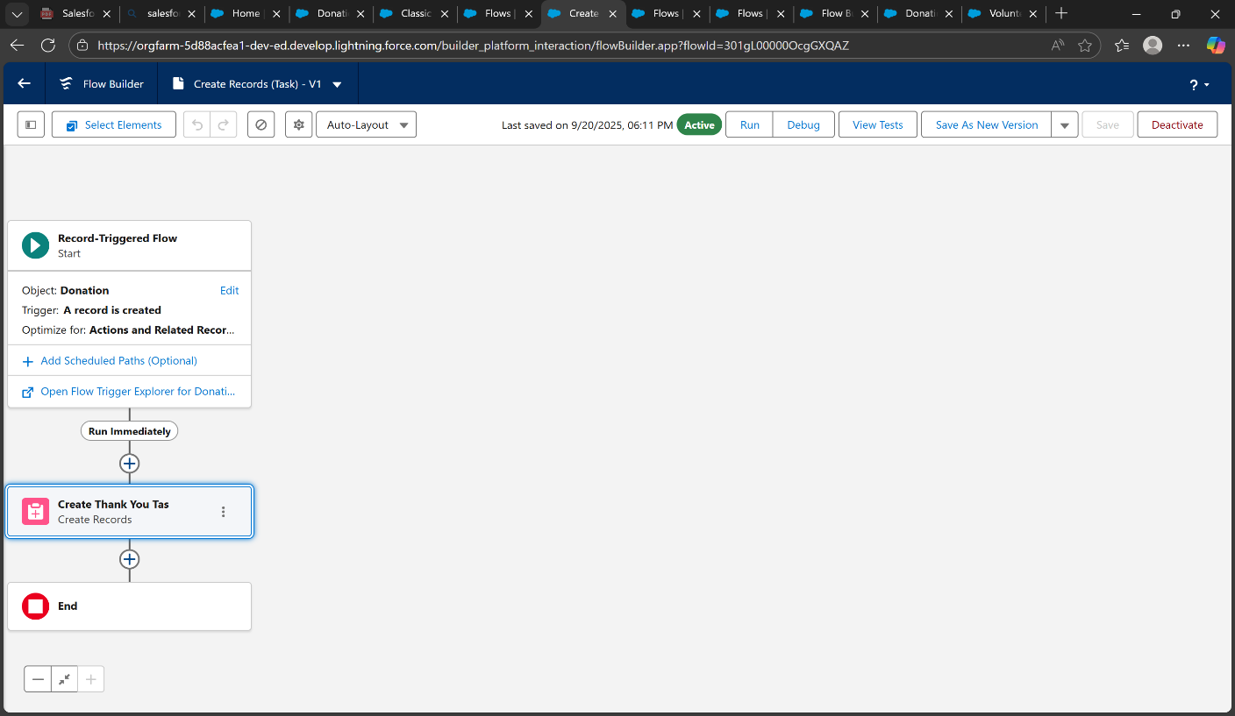

**6) Email Alerts**

* Create **Lightning Email Template** → Setup → Email Alerts → attach to Flow/Workflow/Approval
* 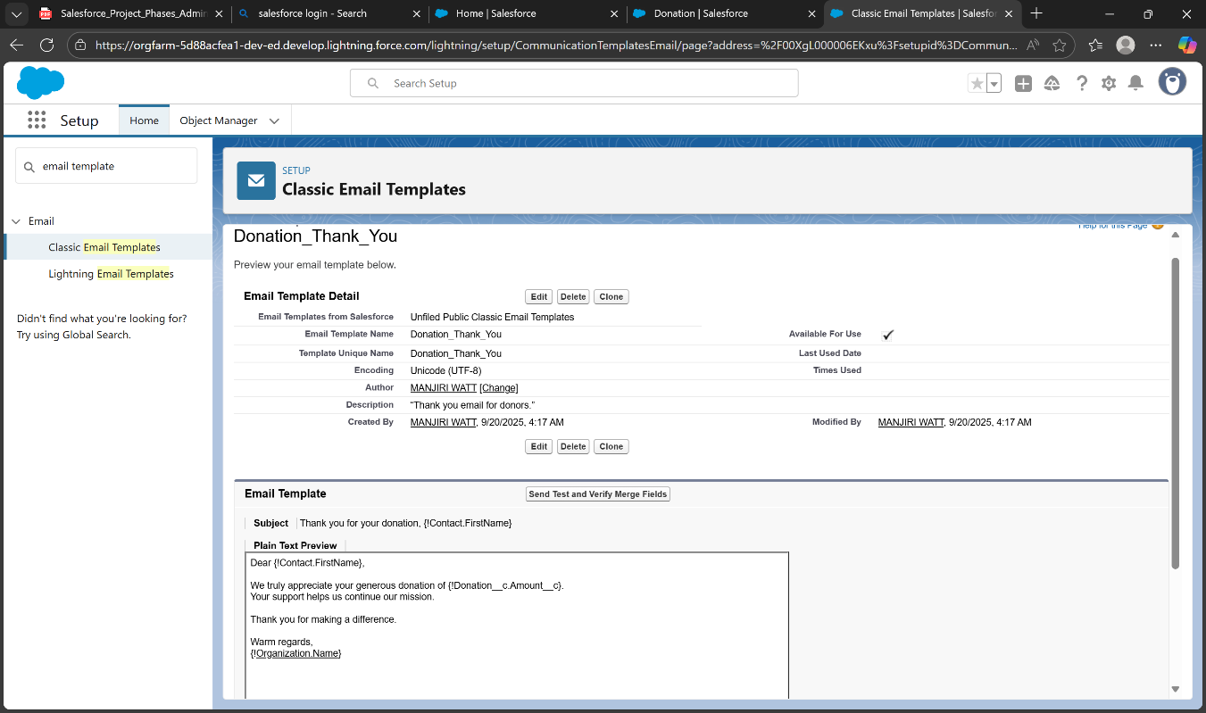Use merge fields for dynamic content (e.g., donor name, donation amount)

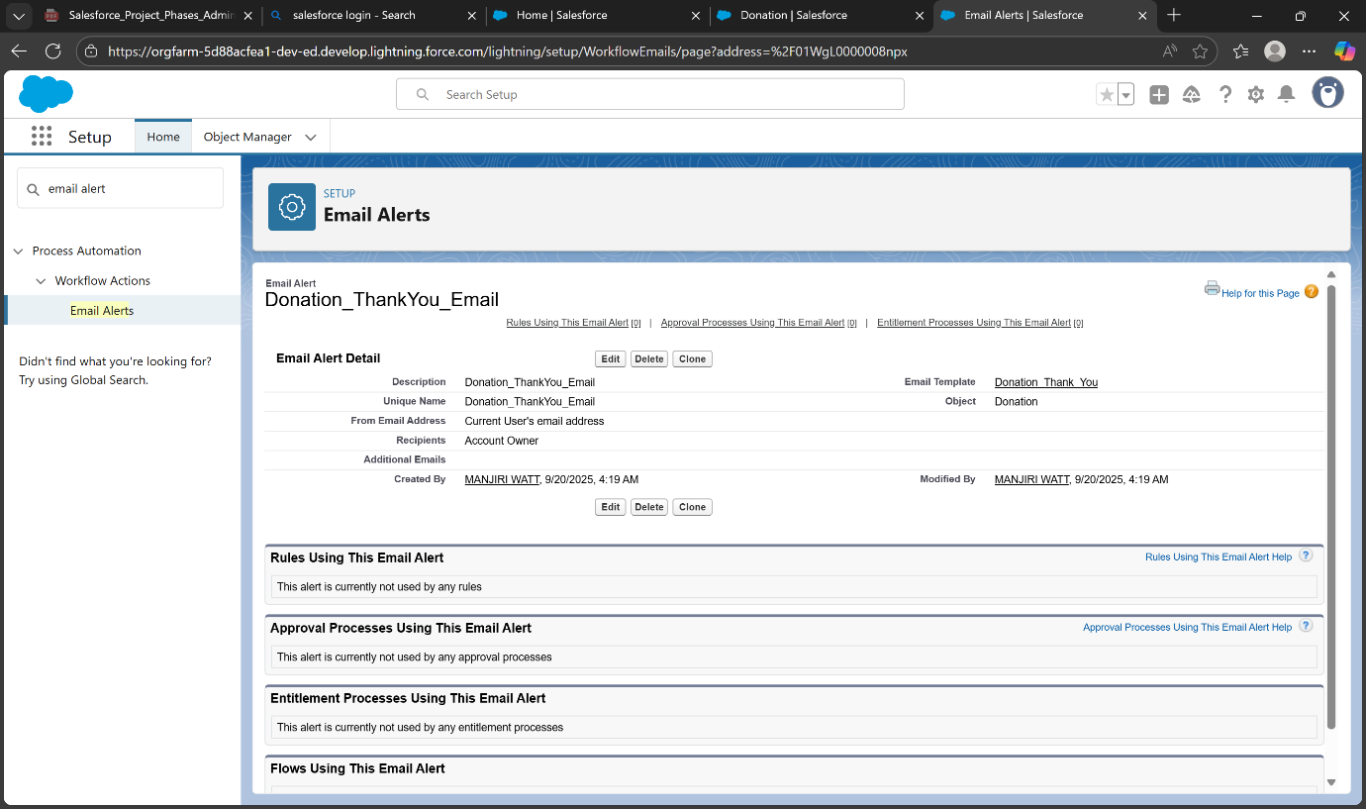**7) Field Updates**

* **Flow:** Update $Record fields automatically (e.g., Acknowledged__c = True)
* **Legacy:** Workflow Field Update → attach to Workflow or Approval Process

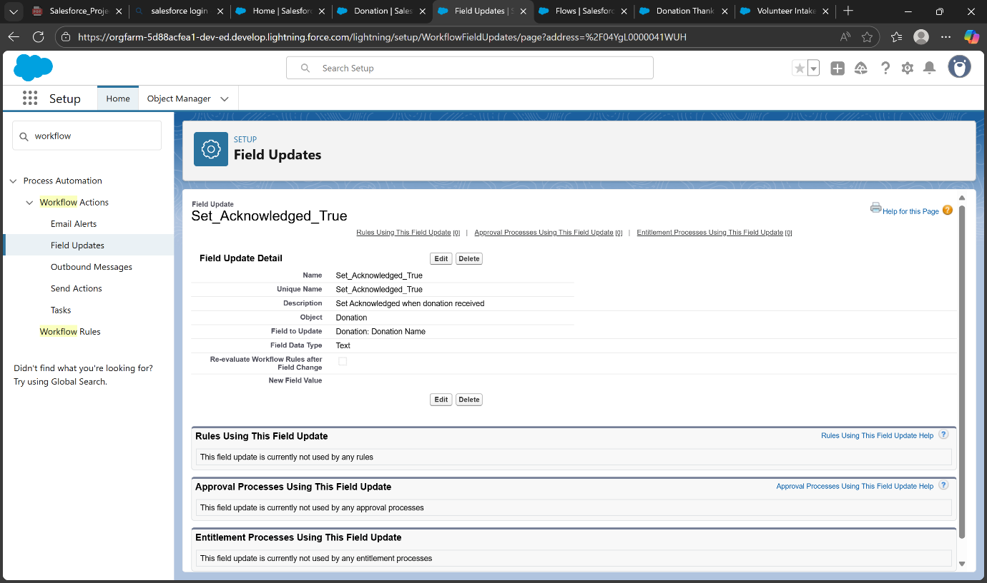

**8) Tasks**

Flow Create Records → map fields:

* + Subject = Send Thank You - {!$Record.Name}
  + WhoId = $Record.Donor__c, WhatId = $Record.Id
  + OwnerId = $Record.OwnerId, Status = Not Started, Priority = Normal

**9) Custom Notifications**

* Setup → Notification Builder → New → Name: New_Donation_Notification → Channels: Desktop & Mobile
* Flow → Action → Send Custom Notification → Title, Body, Recipient Ids → Activate

**Phase 5 – Apex Essentials**

**1) Classes**

* **Use:** Store reusable logic and calculations.
* **Example:** Calculate total donation including taxes or fees.
* 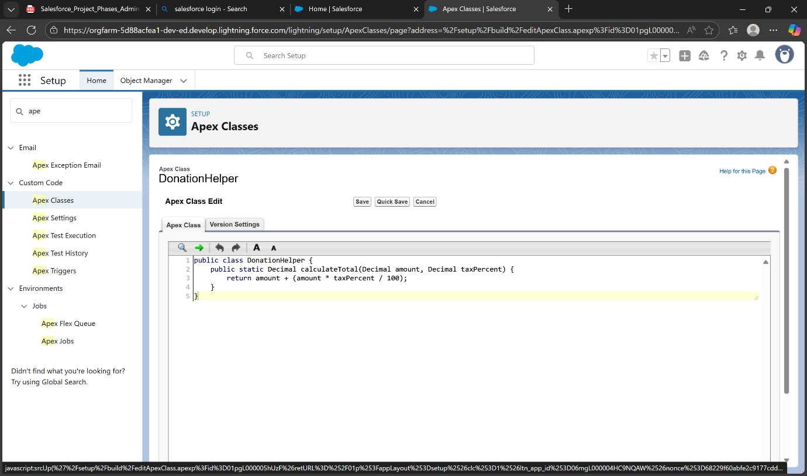**Setup:** Setup → Apex Classes → New → Add calculation methods → Save

**2) Triggers**

* **Use:** Automatically update fields or perform actions when donations are created or updated.
* **Example:** Set **Priority = High** if donation ≥ ₹1,000, else **Normal**.
* **Setup:** Setup → Apex Triggers → New → Select Donation → Before Insert → Add trigger logic → Save

**3) SOQL**

* **Use:** Query and retrieve records from Salesforce.
* **Example:** Fetch all donations with Amount ≥ ₹1,000.
* 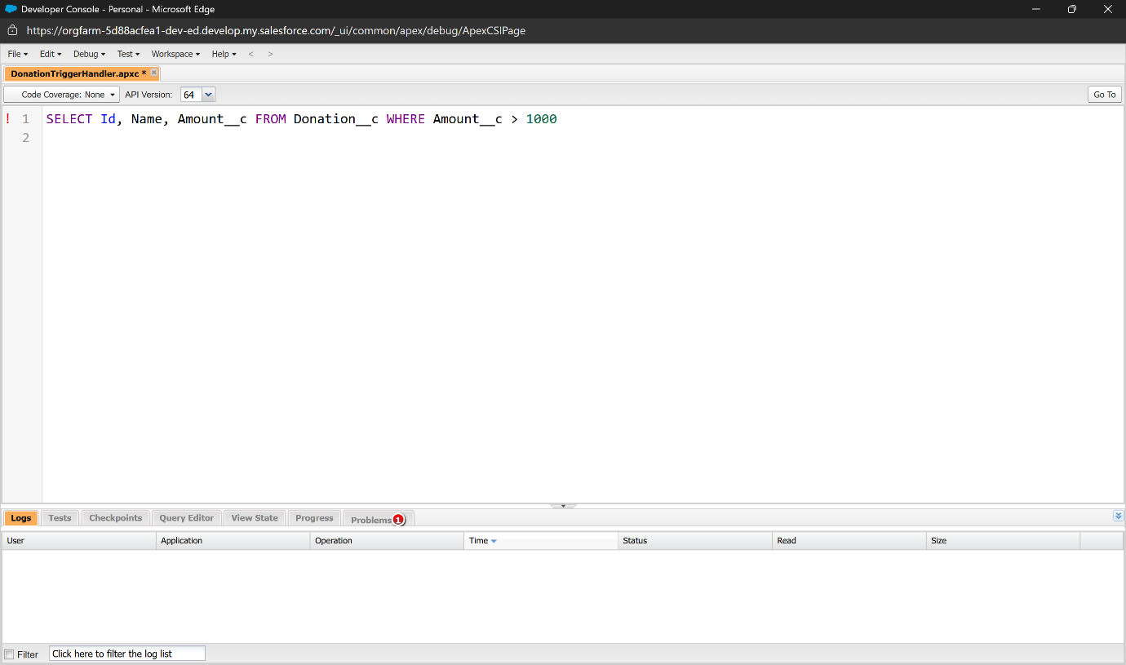**Setup:** Developer Console → Query Editor → SELECT Id, Name, Amount__c FROM Donation__c WHERE Amount__c >= 1000 → Execute

**4) Collections**

* **Use:** Store and manage multiple records efficiently.
* 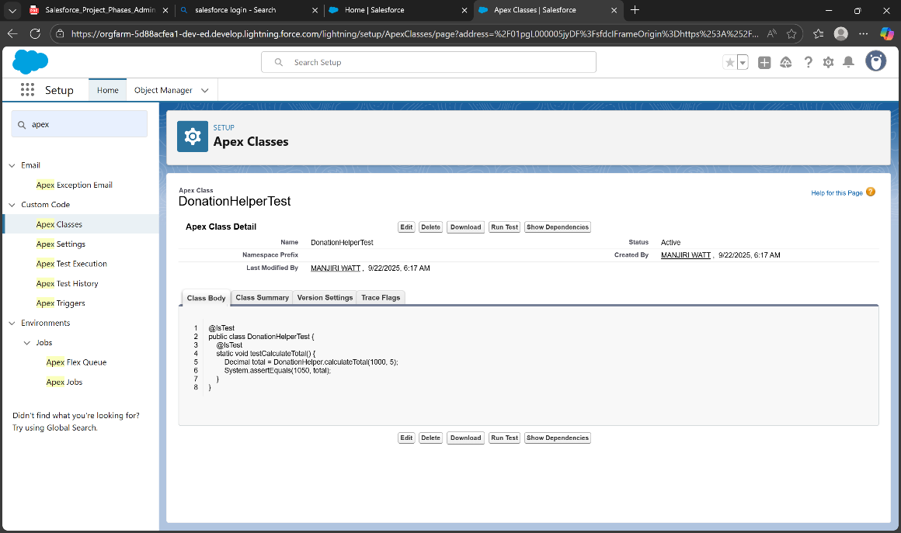**Example:** List of donors; Map linking donor names to donation amounts.**Setup:** Developer Console → Execute Anonymous → Define Lists/Maps → Execute → CheckDebug Logs

**5) Test Classes**

* **Use:** Verify that Apex code works correctly and is deployable.
* **Example:** Test DonationHelper class calculation method.
* **Setup:** Setup → Apex Classes → New → Create test methods → Save → Run in Apex Test Execution

**Phase 6**

**1) Lightning App Builder**

**Purpose:** Customize pages without code.

**Steps:**

1. Go to **Setup → Lightning App Builder → New**.
2. Choose **App Page**, **Home Page**, or **Record Page** depending on your need.
3. Give the page a **name** and click **Next**.
4. Use the **drag-and-drop editor** to add components like charts, lists, or key metrics.
5. 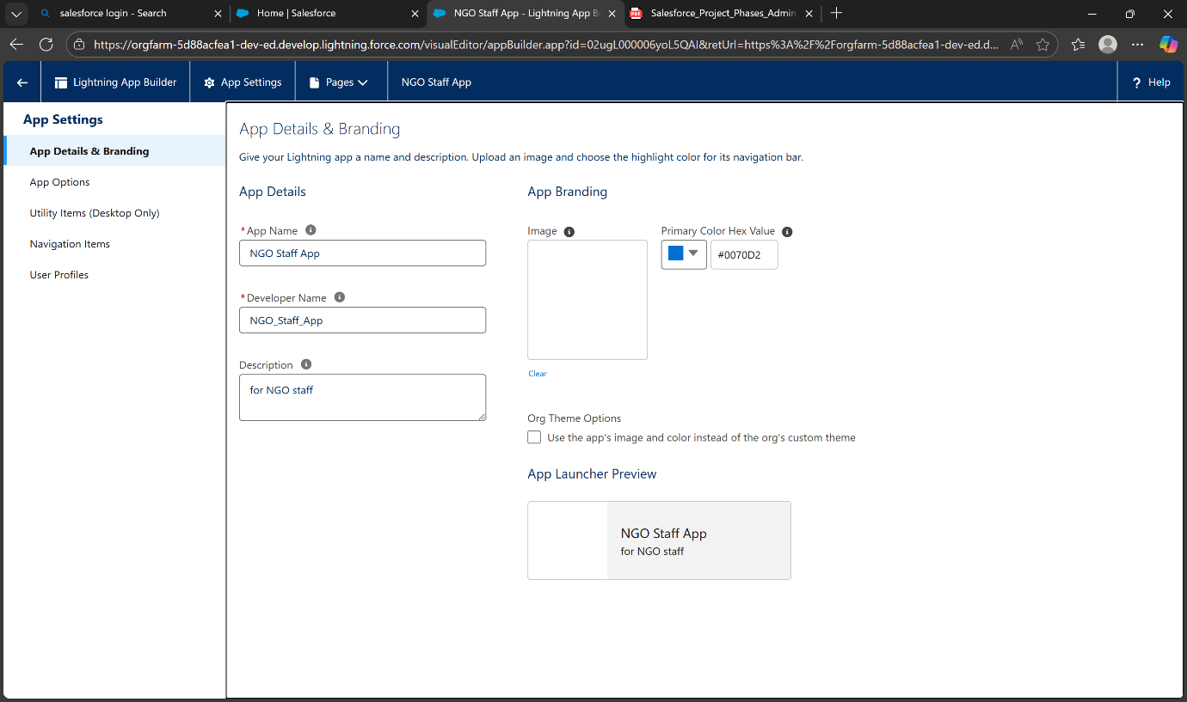Click **Save** → **Activate** → Choose where the page will be visible (Org Default, App Default, or Profile-specific).

**2) Record Pages**

**Purpose:** Customize how individual records (like Donations) are displayed.

**Steps:**

1. Go to **Setup → Lightning App Builder → Record Page → New**.
2. Select the object (e.g., **Donation**) and give the page a **name**.
3. Arrange components such as **Record Details**, **Related Lists**, and **Reports/Charts**.
4. Click **Save** → **Activate** → Set visibility for **Org Default or specific App/Profile**.

**3) Tabs**

**Purpose:** Organize Salesforce apps and make navigation easier.

**Steps:**

1. Go to **Setup → App Manager → Edit App**.
2. Click **Navigation Items** → Add the objects or tabs you want (e.g., Donations, Contacts, Reports).
3. Rearrange tab order if needed.
4. 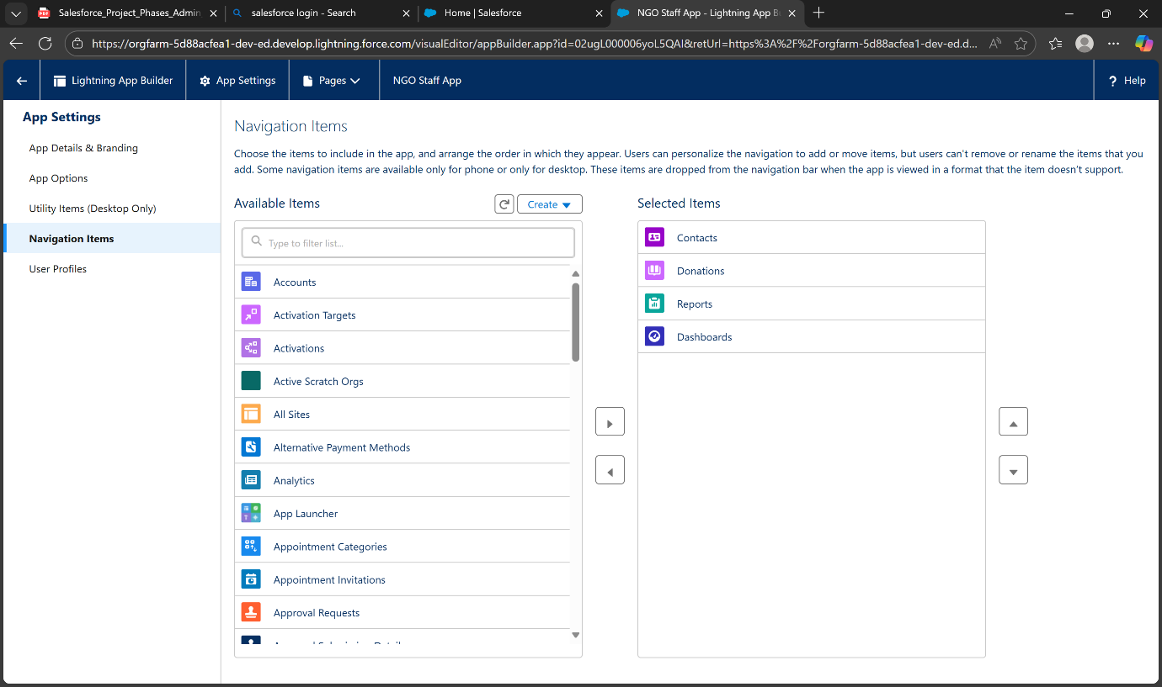Click **Save** → Open the app to verify tabs appear correctly.

**4) Home Page Layouts**

**Purpose:** Display important metrics, charts, and quick actions on the homepage.

**Steps:**

1. Go to **Setup → Lightning App Builder → Home Page → New / Edit**.
2. Use the **drag-and-drop editor** to add components like **Key Metrics**, **Report Charts**, and **Tasks**.
3. Adjust layout and sections as needed.
4. Click **Save** → **Activate** → Choose visibility (Org Default or specific profiles).

**5) Utility Bar / Utility Items**

* **Use:** Provide quick-access tools at the bottom of the app (e.g., Notes, Recent Items, Tasks).
* **Steps:**
  1. Go to **Setup → App Manager → Edit App → Utility Bar**.
  2. Click **Add** to include components like **Notes, Recent Items, or Custom Tools**.
  3. Configure **labels, icons, and order** of items.
  4. 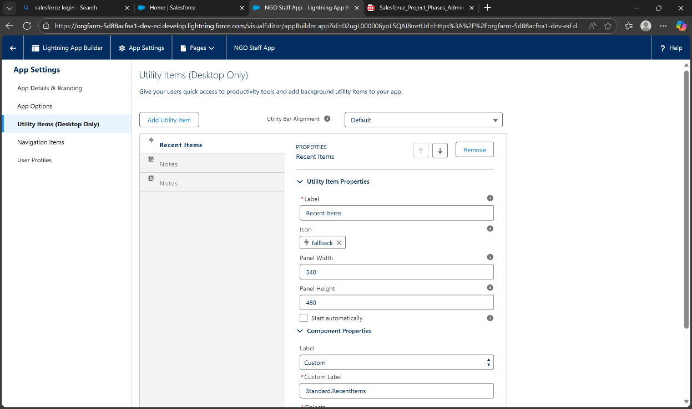Click **Save** → Activate the app.